Nat 4 English 2014-15 Miss McDougal
National 4 | National 4 is made up of 3x Units and 1x Added Value Unit  All parts of the course are internally assessed  National 4 is assessed on a Pass/Fail basis
Unit  Assessments | - Analysis and Evaluation (Reading & Listening)  - Understand, Analyse and Evaluate straightforward texts.  - Understand, Analyse and Evaluate straightforward spoken language.  2. Creation and Production (Writing & Talking)  - Create and produce straightforward written texts.  - Take part in straightforward spoken interactions.  - Literacy Unit (Reading, Writing, Listening, Talking)  - Read and understand straightforward word-based texts.  - Listen to and understand straightforward spoken communication.  - Write straightforward technically accurate texts.  - Talk to communicate, as appropriate to audience or purpose.  To achieve the N4 Course Award pupils must pass all Outcomes of all Units
The Added Value Unit

Apply language skills to investigate a chosen topic.
Presentations must be written or spoken

Written
An extended piece of writing in the form of a critical, informative, argumentative essay or report. 700-800 words long.

Or Spoken
At least 5 minutes long and in front of an audience of at least 3.

Pupils will also have to respond to questions on their presentations.

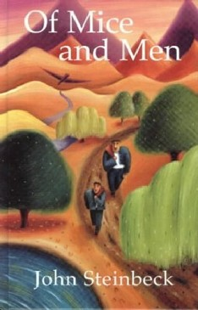  National 4 texts | Of Mice and Men John Steinbeck,  Romeo and Juliet William Shakespeare  Romeo and Juliet – Baz Luhrman  A Selection of Dramatic Monologues Carol Ann Duffy  Sherlock Holmes Arthur Conan Doyle  Animal Farm George Orwell  A selection of War Poetry

