National 4 English 2014-2015 – Mr Christensen
Internal assessment:  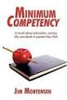  3 Unit Assessments | - Analysis and Evaluation  -listening and reading  - Creation and production  -Speaking and writing  3. Literacy  -Reading, Listening, Writing, Speaking  These are formal unit assessments which assess minimum competency to ensure pupils the minimum standard of ability.  Students must pass all unit assessments focusing on each discreet skill in order to be presented for National 4. Only one resit is allowed.
Added Value Unit | Apply language skills to investigate a chosen topic.  Presentations must be written or spoken  Written  An extended piece of writing in the form of a critical, informative, argumentative essay or report. 700-800 words long.  Or Spoken  At least 5 minutes long and in front of an audience of at least 3.  Pupils will also have to respond to questions on their presentations.
Set Texts  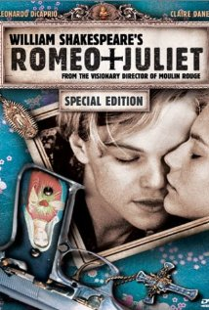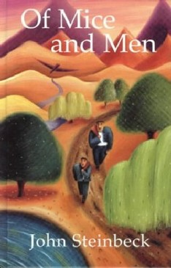  Prose: ‘Of mice and men’, John Steinbeck  Drama: ‘Romeo and Juliet’, William Shakespeare  Poetry: A selection of War Poetry | - Read and understand straightforward word-based texts.  - Listen to and understand straightforward spoken communication.  - Write straightforward technically accurate texts.  - Talk to communicate, as appropriate to audience or purpose.

