Higher English 2014-15 Mr Bryson
Unit  Assessments  Deadline: December 2014 | - Analysis and Evaluation  -The minimum standard must be reached in Close Reading.  -The minimum standard must be reached in Listening.  - Creation and Production  -The minimum Writing standard must be reached in a Writing piece.  -The minimum standard must be reached in Talking.  These are formal assessments which assess minimum competency to make sure pupils are on the right course.  Students must pass both Units in order to be presented for Higher.  Only one resit is allowed.
Deadlines:  Preliminary: December 2014  Final: End of February 2015 | The Writing Folio- 30%  - Creative  Develop a central concern using effective structure and effective language.  -Personal Writing OR  -Short Story/Drama/Poetry  Develop an argument on an issue and demonstrate ability to create effective tone, structure and language.  - Persuasive Essay
Exam Paper 1: Reading for Understanding, Analysis and Evaluation – 30%

Students must answer questions on Two Passages in 1hr 30 minutes.

Students must demonstrate their ability to answer…
Understanding Questions- use own words to explain key aspects of texts.
Analysis Questions- identify and explain language techniques of Imagery, Sentence Structure, Tone.
Evaluation Questions- identify effective aspects of text and explain effectiveness.
The final Question- explore 3 similarities and/or differences in the two texts.
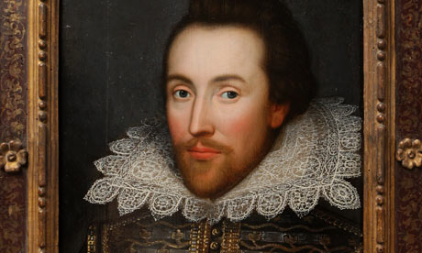  Scottish Text Prose: The Cone Gatherers by Robin Jenkins  Poetry: Gerard Manley Hopkins, Christina Rosetti, W.H Auden, Seamus Heaney  Drama: Hamlet by William Shakespeare | Exam Paper 2: Critical Reading - 40%  1. Students must complete a Textual Analysis of a Scottish Text in 45 minutes (20%).  This year’s text will be The Cone Gathers by Robin Jenkins.  A section of the text will be printed in the exam.  Students must answer several questions relating to this section and one final question relating to the text as a whole.  2. Students must write a critical essay in 45 minutes (20%).  Pupils must demonstrate effective…  Understanding- of the text and of the question.  Analysis- of textual references in depth.  Evaluation- of the effectiveness of textual references.  Expression- of essay must be precise, structured and technical.

