Literacy Across Learning Strategy 2014-2018

- LAL Whole School Focus Areas
- Departmental Literacy Specialisms
- Skills Frameworks: Research and Presentation
- Relevance, Resilience and Success: Celebrating Literacy

Every Subject, Every Day: Building Habits of Excellence

1. Literacy Across Learning Whole School Focus | 2014-15 IMPACT YEAR | 2015-16 – 2016-18 IMPACT YEARS
Writing  In every subject, every day,  I use the little orange  Vocabulary and Spelling jotter to  record and use new words  check spellings  In every subject, every day,  I give myself a Literacy aim   when writing  I review and edit my work with   pride  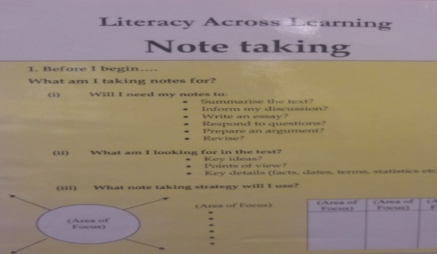  Reading and Listening  In every subject, every day,  I use the advice on the classroom  posters to develop my note-taking  and summarising skills  Talking In every subject, every day, I consider the success criteria for discussions and presentations I can contribute relevantly and clearly. I can remain focused throughout the discussion or presentation. I can engage with and encourage others by using positive body language and eye contact. I can discuss issues in a positive way even when I disagree with comments made.  Literacy Across Learning: Building Habits of Excellence | Where are we now- 2013/14?  - All departments have contributed to the identification of the Literacy Skills opposite as key to raising attainment.  - All pupils have the poster in their homework diaries.  - The LAL poster, note taking poster and Literacy Across Learning quick reference card are available to all teachers.  What’s the plan 2014/15?  - In all subjects, teachers are expected to provide opportunity, when relevant, for pupils to develop the skills opposite.  - All departments will include the plan to consistently provide opportunity for pupils to develop these skills in the 2014-15 Action Plans.  How do we know it’s having an impact?  - Self-evaluation of all departments will consider the consistency with which pupils experience opportunity to develop the identified skills.  - Pupil surveys in October and May will be conducted- to ascertain how consistently they are developing the identified skills across the curriculum.  - Learner conversations will take place in October and May to gauge the pupil perspective.  - Attainment progression in Reading, Writing and Talking and Listening is routinely conducted from S1 to S3 in English. | 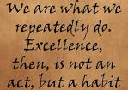  What’s the plan 2015/16 and beyond?  - Pupils will habitually experience the identified skills, where relevant, in all classrooms.  - At identified sharing of good practice sessions/inservice, staff will consider how best to develop the core skills of editing, note-taking, summarising, discussing etc through levels 2/3/4.  - The Literacy website will feature examples of good practice, examples of level-related work and celebrate achievement.  - Pupils will take ownership of the LAL website- designing pages, uploading work etc  How do we know it’s having an impact?  - A range of QA measures will ascertain the consistency of pupil experience and evaluate the pupil perspective.  - Resources and sharing of good practice sessions will be created and time-tabled.  - Samples of evidence of attainment in Reading, Writing and Talking and Listening will be taken across the curriculum.

2. Departmental Literacy Specialisms | 2014/15 Development Year | 2015/16 Impact Year | 2016-2018 Impact Years
Where are we now-2013/14?  - All departments have identified Literacy E/Os, in addition to the whole school Focus areas, in which to specialise.  - A calendar of Departmental specialisms has been created.  - Departments which have selected the same E/O have been identified. The time of year when Departments focus on their selected E/O has been identified (whether specific or ongoing). | What’s the plan 2014/15?  Teaching and Learning sessions will be dedicated to the following:  - Supported by leaders of literacy (from the literacy group and English Faculty) all Departments will create and adapt resources to emphasise and develop pupils’ experience of their chosen literacy specialism. Teaching and Learning Community meetings will be set aside for this (starting in the Autumn Term).  - Supported by leaders of literacy (from the literacy group and English Faculty), all teachers will develop confidence in identifying success criteria in their chosen specialism and share good practice in TLC meetings.  - In May/June 2015, Departments will link with other departments to share good practice and develop IDL opportunities and contexts where meaningful.  - A range of resources will be created and shared and made available on the Literacy website.  How do we know it’s having an impact?  - Literacy surveys and TLC learner conversations will establish the pupil perspective.  - Teacher feedback will be gathered to evaluate the impact of Literacy specialisms on attainment.  - Pupil work will be sampled across the curriculum. | What’s the plan 2015/16?  By Aug 2015, all Departments will have created/modified resources and have shared good practice re the delivery of the chosen Literacy specialism. In 2015/16 the focus will be as follows:  - Supported by leaders of literacy (from the literacy group and English Fac), in dedicated TLC meetings, Departments will combine to share and reflect on good practice re Literacy.  - According to plans developed in May/June 2015, Departments will engage with other Departments in developing Literacy skills in IDL contexts.  - Pupils will create IDL features to display in school corridors/library and on the website.  How do we know it’s having an impact?  - Literacy surveys and TLC learner conversations will establish the pupil perspective.  - Teacher and pupil Literacy surveys will be conducted.  - Pupil work will be sampled across the curriculum.  - Display will be visible in school, highlighting the transferability of Literacy skills. | What’s the plan 2016-18?  According to the success of the foregoing, Departments will broaden their Literacy focus to develop further Literacy specialisms.  - Supported by leaders of literacy, all Departments will create and adapt resources to highlight and emphasise further literacy specialisms. Teaching and Learning Community meetings will be set aside for this.  - Supported by leaders of literacy, all teachers will develop confidence in identifying success criteria in a range of Literacy E/Os and share good practice in TLC meetings.  - In May/June 2015, Departments will link with other departments to share good practice and develop IDL opportunities and contexts where meaningful.  - A further range of resources will be created and shared and made available on the Literacy website.  How do we know it’s having an impact?  - Literacy surveys and TLC learner conversations will establish the pupil perspective.  - Pupil work will be sampled across the curriculum.  - Teacher/Faculty feedback will be sought re attainment.

3. Skills Frameworks: Research and Presentation | 2014/15 Development Year | 2015/16 Impact Year | 2016-2018 Impact Years
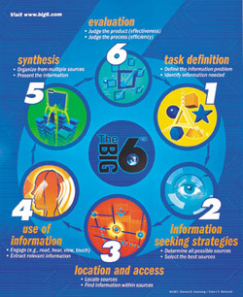  Where are we now- 2013/14?  - Pupils undertake a great deal of research across the curriculum.  - Pupils deliver presentations- whether written or spoken- in all subjects.  - No consistent skills framework for research and presentation currently exists to highlight the transferability of skills and promote the independent application of skills in unfamiliar contexts. | What’s the plan 2014/15?  A Skills Framework for Research and Presentation will be developed for pupils to apply across the curriculum and in unfamiliar contexts.  - Members of the Literacy Group will gather research projects and related resources from across the curriculum (June 2014).  - A Skills Framework (a guide and checklist) will be created based on departmental requirements in the form of a mat or fan for use across the curriculum (by December 2014).  - Opportunities will be timetabled for S3 pupils in CFE and/or LFE classes to apply the Skills in unfamiliar contexts.  - When conducting research projects and presentations, teachers will highlight the transferability of the research and presentation skills by using the Skills Frameworks when appropriate.  How do we know it’s having an impact?  - The literacy Group/TLC will sample research projects across the curriculum.  - Teacher and pupil Literacy surveys will be conducted.  - Learner conversations will ascertain the pupil perspective.  - Attainment in AVU will improve measurably. | What’s the plan 2015/16?  - By the end of the year, teachers will habitually refer pupils to the Skills Frameworks. This will be a feature of Faculty Action plans 2015/16.  - Pupils will recognise the relevance of the Skills Frameworks and have opportunity to apply the skills across the curriculum and in CFE and/or LFE classes.  - Pupils will celebrate their achievements by displaying work throughout the school and on the school website. Excellence will be celebrated through Literacy Awards and collated by S6 Leaders of Literacy.  How do we know it’s having an impact?  - The literacy Group/TLC will sample research projects across the curriculum.  - Teacher and pupil Literacy surveys will be conducted.  - Learner conversations will ascertain the pupil perspective.  - Attainment in AVU will improve measurably.  - Website will be developed to celebrate achievement and ‘Leaders of Literacy’ will be awarded. | What’s the plan 2016-18?  According to the success of the foregoing, Skills Frameworks will be modified and extended to include a greater range of Literacy Skills.  - Members of the Literacy Group will explore further opportunities to develop Skills Frameworks for a greater range of activities commonly undertaken across the curriculum.  - Further Skills Frameworks (guides and checklists) will be created based on departmental requirements in the form of mats or fans etc for use across the curriculum.  - Opportunities will be exploited for pupils in CFE and/or LFE classes to apply the Skills in unfamiliar contexts.  How do we know it’s having an impact?  - The literacy Group/TLC will sample pupils’ work across the curriculum.  - Teacher and pupil Literacy surveys will be conducted.  - Learner conversations will ascertain the pupil perspective.  - Website will be developed to celebrate achievement and ‘Leaders of Literacy’ will be awarded

4. Celebrating Literacy | 2014/15 Impact Years | 2015-18Impact Year
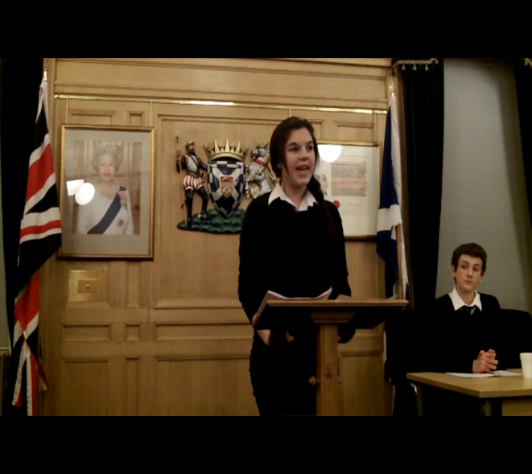  Where are we now- 2013/14?  Literacy is celebrated in the following ways:  - Pupil work with a Literacy focus is occasionally displayed in corridors.  - Reading Certificates are issued for Excellence and Commitment to S1/2/3 pupils.  - Pupil success in Public Speaking, Debating, Drama, Writing Competitions and in social contexts is celebrated although not necessarily as an achievement in Literacy.  - Pupils who demonstrate a commitment to developing the skills of others are recognised but not necessarily as leaders of Literacy. | What’s the plan 2014/15?  A range of Whole School Literacy Awards will be introduced to celebrate achievement in Literacy at EHS- including the appointment of Leaders of Literacy who will fulfil a number of roles including helping young people with Literacy across the curriculum.  The Literacy Group is creating a website which will promote Literacy and celebrate achievement in Literacy.  - The website will be a resource for teachers to share good practice and standards.  - The website will be a resource for pupils where the transferability of Literacy skills is highlighted; where successful examples of work can be found from across the curriculum; where book reviews can be posted and shared.  - The website will be a resource for parents where they can access information and find resources with which to support their young people.  - The website will celebrate achievement in Literacy by publicising the achievements of pupils awarded a whole School Literacy Award.  How do we know it’s having an impact?  - A range of pupil/parent/teacher feedback will be sought by the Literacy Group and English Faculty.  - Teacher and pupil surveys will be conducted to gauge the usefulness of the site and how to improve it. | What’s the plan 2015-18?  - Leaders of Literacy will increasingly take ownership of the Literacy website by displaying pupil work and celebrating pupil achievement in Literacy.  - Resources for staff will be continually updated and renewed in order to share the best practice and institute a common understanding of levels.  How do we know it’s having an impact?  - A range of pupil/parent/teacher feedback will be sought by the Literacy Group and English Faculty.  - Teacher and pupil surveys will be conducted to gauge the usefulness of the site and how to improve it.  